Julie Lazor

Alex Pakalniskis

GISC 606

22 April 2023

*The Use of Remote Sensing for Deep Space Exploration*

Space is a duality of nothing and everything. There are so many marvels and mysteries that lie beyond the void but also infinite spans of matter that we have not yet been able to quantify or understand. As technology has advanced, we have turned to satellites and respective sensors to be able to venture where mankind can not and to seek more answers as to what lies before us in the Final Frontier. There have been numerous satellites which have been launched to explore deep space. The purpose of some of these satellites has been to detect gamma rays, microwaves, neutrinos, and high-resolution images of planets, moons, and other outer-space features. This research has a direct impact on how we understand our creation of Earth and self and shapes how we understand the laws and theories that operate our universe and Earth.

I chose this topic because I am very interested in pursuing a career in space technology. I believe in order to understand our world and selves, it is important to fully understand where we came from. Furthermore, there is so much we are learning from space but yet so much more we do not know. I would find it exciting to be able to be a part of an exploration that shapes our understanding of the universe and answers the questions of our life’s mysteries.

Much of space exploration and research happens beyond the scope of our visual observations. Gamma Rays are a form of electromagnetic radiation that is not visible to the human eye and have one billion times the energy of visible light. Gamma rays cannot penetrate Earth’s atmosphere and are typically associated with high-energy environments such as supermassive black holes, merging neutron stars, exploding stars, streams of hot gas moving close to light speed, and more (Dunbar, 2015). These events are but a few examples of instances in our universe where gamma radiation is generated but studying these events and measuring this radiation allows scientists to be able to explore phenomena about which we still know very little.

The research of high energy gamma radiation yields information regarding physical processes in extreme environments and new physics. Gamma rays can also indicate the density of extragalactic background light (EBL) which permeates the edge of the universe. Gamma rays are primarily unaffected once they are released from their source of creation and if the energy is high enough, these waves can interact with EBL and thus can also indicate rates of star formation (Michelson, et al, 2010).

One application of remote sensing which has been used to study gamma rays in space is the Fermi Gamma-Ray Space Telescope which is an imaging, wide field-of-view telescope. It covers the energy range of 20 MeW to 300 GeV. The primary instrument onboard the Fermi is the Large Area Telescope (LAT) which was built with international collaboration. The primary objectives of the LAT include: (1) Determining the nature and sources of unidentified diffuse emissions which were captured by EGRET (another satellite); (2) understanding the mechanisms of particle acceleration in celestial sources; (3) understanding the high-energy behavior of GRBs and transients; (4) using gamma-ray observations as a probe of dark matter; and (5) using high-energy gamma rays to probe the early universe and the cosmic evolution of high energy sources (Atwood, et al, 2009).

The LAT works by measuring the tracks of electrons and positrons which occur when an incident gamma ray undergoes pair-conversion, preferentially in a thin, high-Z foil. This measures the energy of the electromagnetic shower of electromagnetic energy that develops in the calorimeter. The LAT is designed to have a good angular resolution for source localization and multiwavelength studies as well as have a high sensitivity over a broad FOV. In having a broad FOV, the sensor is better able to monitor variability and detect transients. The sensor is also equipped with good calorimetry over an extended band to study spectral breaks and interruptions and good calibration to ensure absolute and long-term flux measurement (Atwood, et al, 2009).

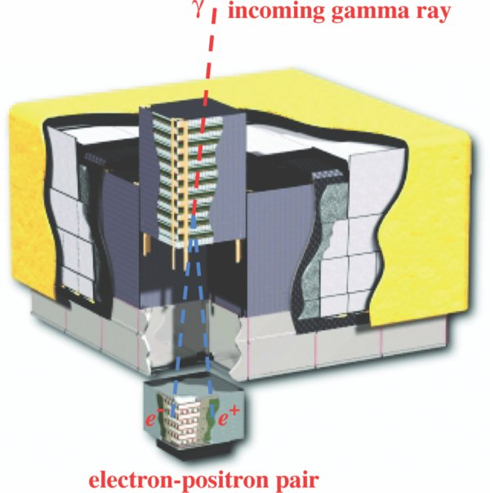

**Figure 1**. Schematic Diagram of LAT.

The Fermi Gamma-Ray Space Telescope has been in orbit for more than ten years and can be attributed to numerous scientific discoveries. Some of these have been the discovery of the largest gamma-ray blast ever seen by scientists which were from a mysterious source and had more energy than 9000 supernovas. The findings of the telescope also confirmed the theory that cosmic rays are derived from supernovas or violent star explosions. With the evidence found from the Fermi telescope, this theory was able to be confirmed (Weitering, 2018). In addition to these findings, the Fermi telescope has been able to provide evidence for many of the theories that shape our understanding of the universe and related matter.

Atwood1, W. B., et al. “IOPscience.” *The Astrophysical Journal*, IOP Publishing, 8 May 2009, https://iopscience.iop.org/article/10.1088/0004-637X/697/2/1071/meta.

Dunbar, Brian. “What Is the Fermi Gamma-Ray Space Telescope?” NASA, NASA, 1 June 2015, <https://www.nasa.gov/audience/forstudents/5-8/features/nasa-knows/what-is-the-fermi-telescope-58.html>.

Michelson, P F, et al. “Fermi Gamma-Ray Space Telescope: High-Energy Results from the First ...” IOP Science, IOP Publishing, 14 June 2010, <https://iopscience.iop.org/article/10.1088/0034-4885/73/7/074901>.

Weitering, Hanneke. “NASA's Fermi Space Telescope Celebrates 10 Years of Gamma-Ray Science.” *Space.com*, Space, 13 June 2018, https://www.space.com/40871-fermi-gamma-ray-telescope-10th-anniversary.html.